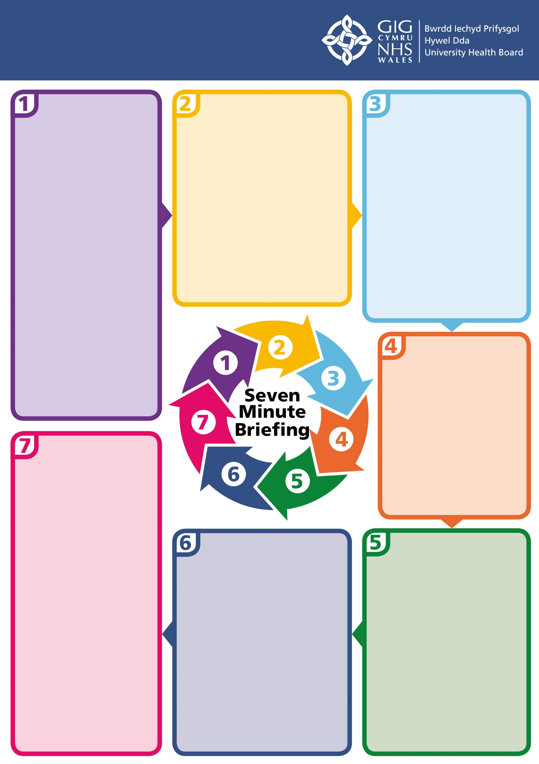

The procedures are not designed to be printed; they are digital only. They will be updated every 6 months.

Welsh Government launched the new Wales Safeguarding Procedures on 11th November 2019.

They replace the All Wales Child Protection Procedures and the Wales Interim Policy and Procedures for the Protection of Vulnerable Adults from Abuse.

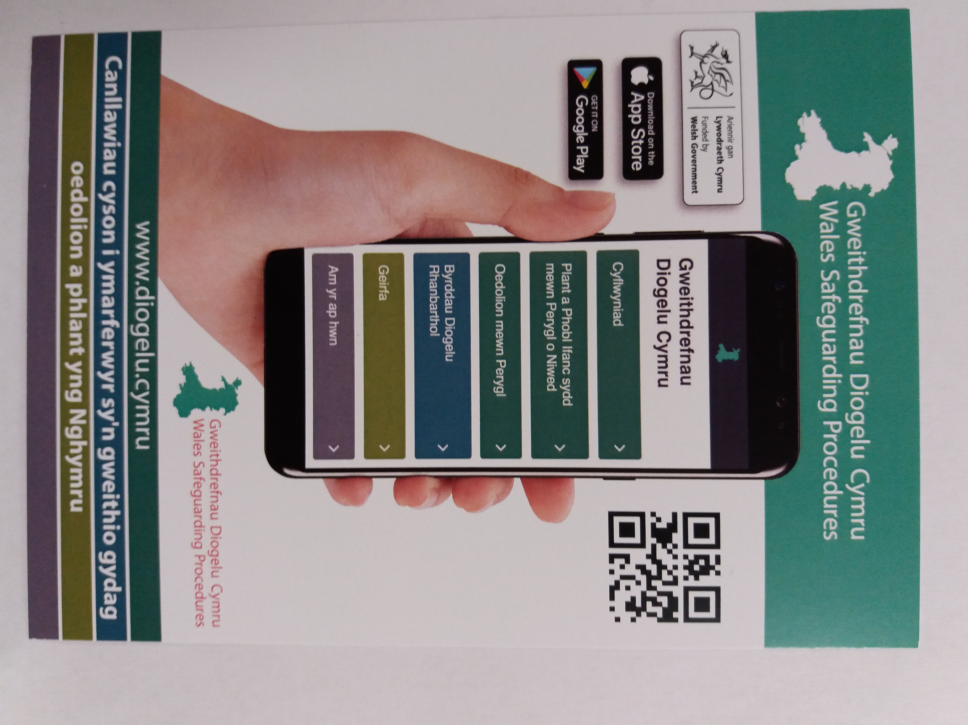

The duty to report is explicit

They outline the duties for Section 47 enquiries and child protection conferences

It includes 10 individual practice guides

The Child Protection Plan is renamed as the Care and Support Protection Plan

**How does this affect me?**

**Professional Concerns**

**What are the changes for children?**

The presumption of capacity is implicit throughout

Advocacy duties are paramount

The adult at risk is central to decision making and there must be communication throughout the process

The statutory duty to report is explicit

No consent does not mean no action

**What are the changes for adults?**

**New Procedures launched**

The procedures are only available in digital form.

The Wales Safeguarding Procedures app is available for download now via the Apple App Store and Google Play Store. They can also be viewed in English at [www.safeguarding.wales](http://www.safeguarding.wales) and in Welsh at [www.diogelu.cymru](http://www.diogelu.cymru).

Regional Safeguarding Boards will be asked to adopt the procedures by January 2020

Training on the procedures is to be rolled out between January and March 2020

Full implementation is expected by April 2020

A desktop version will be available soon

**What next?**

The Wales Safeguarding Procedures will guide safeguarding practice for all those employed in the statutory, third (voluntary) and private sectors in health, social care, education, police, justice and other services.

They apply to all practitioners and managers working in Wales, whether employed by a devolved or non-devolved agency, and whether in paid or unpaid work.

This is a standalone section

It replaces Part IV of the AWCP and Professional Concerns guidance for adults

The approach is consistent for child and adult concerns

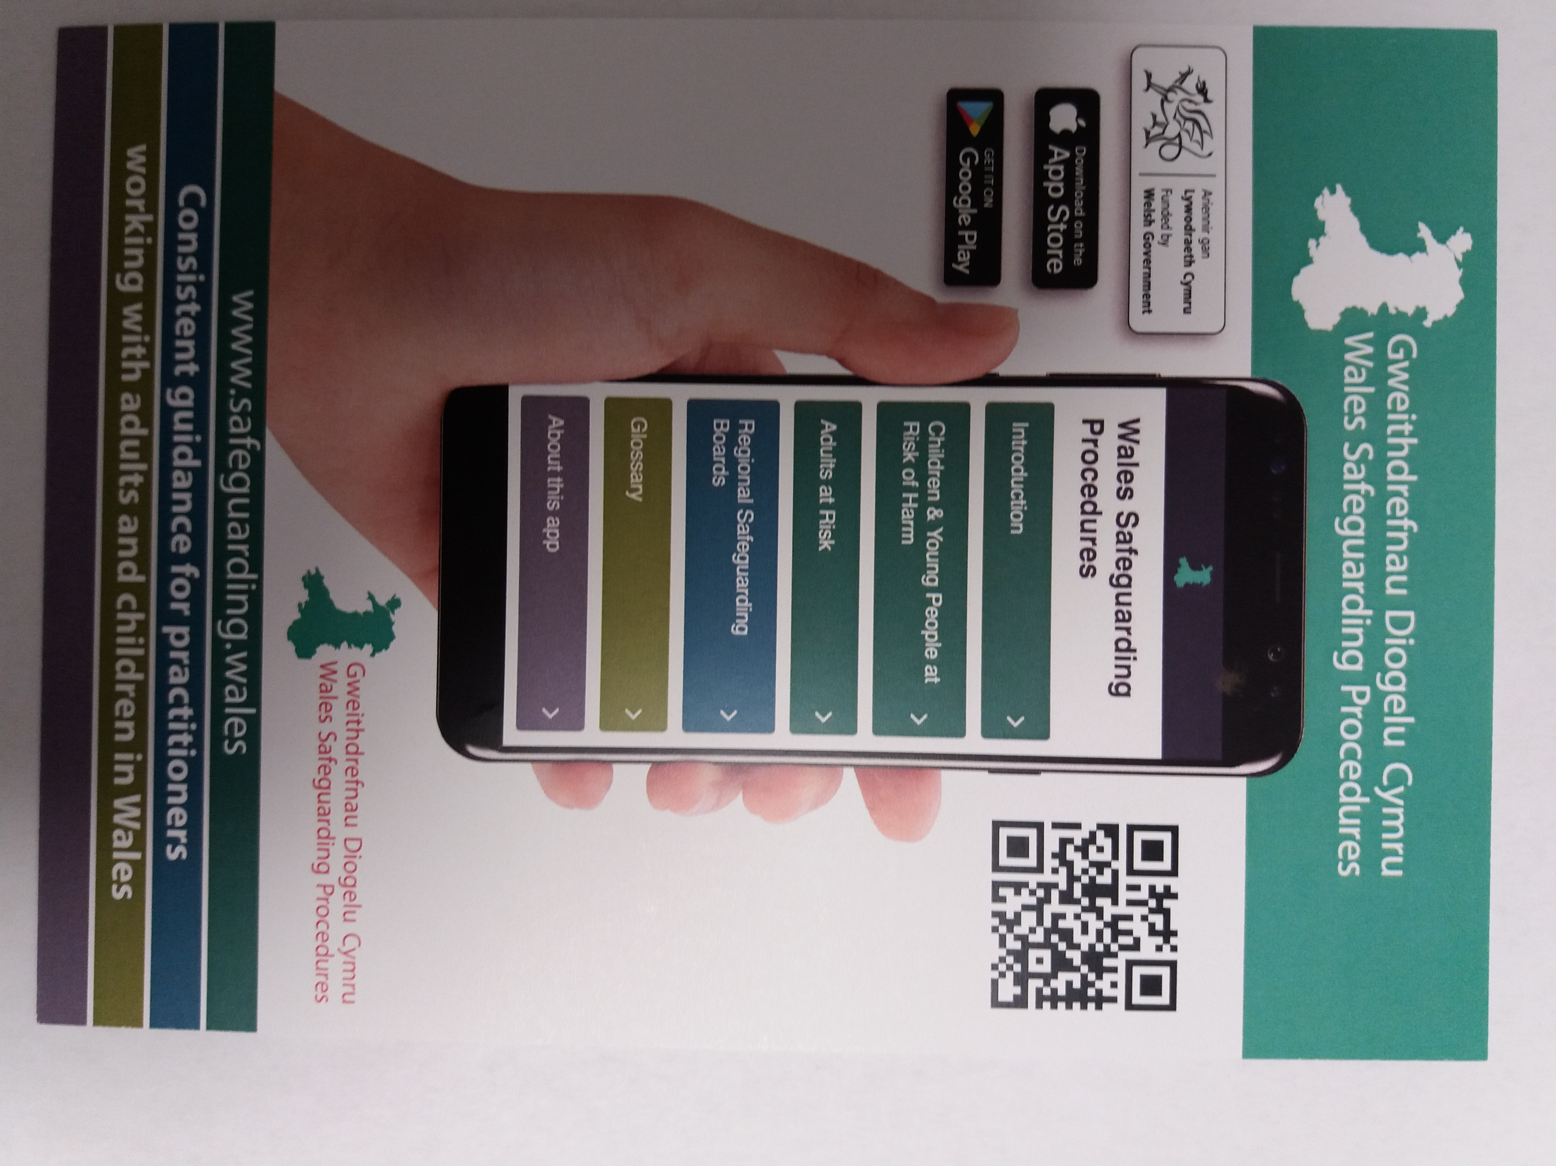

**Wales Safeguarding Procedures 2019**