**Specialist Violence against Women, Domestic Abuse & Sexual Violence Services in Mid and West Wales**

**Wales’ National Live Fear Free Helpline:**  0808 80 10 800

24 hour helpline offering advice and information to survivors, their families and professionals. The helpline holds information on relevant universal and specialist services across Wales.

**Bawso**

Bawso are not currently funded to provide services in the Mid and West region, but will provide advice by telephone on BME needs when they are able to do so.

24 hour helpline: **0800 7318147**

**Calan DVS**

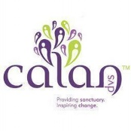Providing refuge and community support in South Powys. Refuge support in the Amman Valley, Carms.) 1 to 1 support for children across south Powys. DASH programme (for children and young people) available in the Amman Valley area. Inspiring Families Programme (whole family support), Recovery Toolkit and Freedom Programme for women that have been affected by domestic abuse, Compass Programme (recovery programme for men) and Active Inclusion project (support project aimed at reducing economic inactivity and improving employability of disadvantaged people) available in all areas that Calan provide support.

Brecon – 01874 625146 Amman Valley – 01269 597474

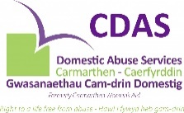

**Carmarthen Domestic Abuse Service:**

Providing refuge support for women and children, including dedicated support for children in refuge. Drop In service. Support available in the community for adults and children. DASH programme (for children and young people 0-16 that have been affected by domestic abuse); Rural Mentoring Project, Money coach.

Office: 01267 238410 Refuge: 01267 234725 1 Stop Drop-in (10 – 1 weekdays) 01267 238410 Former Myrddin Day Centre, Cambrian Place, Carmarthen SA31 1QG.

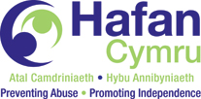

**Hafan Cymru**

Providing refuge service and One Stop Shop in Pembrokeshire. IDVA services across Dyfed Powys. Supported accommodation and floating support for vulnerable women and their families in Pembrokeshire, Carmarthenshire and Powys.

Carmarthen: 01267 225555 Pembrokeshire (Haverfordwest): 01437 768671 Powys (Brecon): 01874 620030

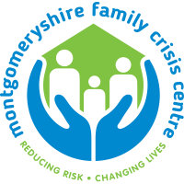

**Montgomeryshire Family Crisis Centre**

Refuge for women, and a separate refuge for men. Dedicated support for children in refuge. Community support also available. Freedom programme and Recovery Toolkit programmes available for survivors to recover from their experiences. STAR club, 1:1 support and play therapy available for children who have experienced domestic abuse to recover from their experiences.

01686 639114 Ty Canol House, Newtown SY16 1AL

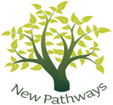**New Pathways**

Counselling to adults who have experienced sexual violence and a counselling service for children (3-17) who have experienced trauma. Sexual Assault Referral Centres (SARCs) and an ISVA service in Aberystwyth, Carmarthen and Newtown. New Pathways provide training on all aspects of sexual violence and related issues across Wales.

Aberystwyth 01970 610124 Bow Street SARC 01970 610124 Carmarthen SARC: 01267 235464

Newtown SARC 01267226166

**Seren Counselling Project**

One to one counselling service for adult survivors of childhood sexual abuse in Carmarthenshire, Ceredigion and Pembrokeshire.

Tel: 0845 4561657 or 01654 700659 PO Box 24. Fishguard, SA65 0AH



**Threshold**

Refuge and community support in Llanelli area of Carmarthenshire. Early Family Intervention Programme, Choices project (behavioural change programme for abusive partners, that includes a women’s safety worker). Male victim support services. Counselling services. Recovery programmes for survivors (Freedom Programme, Recovery Toolkit). Project Y (earlier intervention programme for young people at risk or affected by domestic abuse, including mediation). DASH programme (for children and young people 0-16 that have been affected by domestic abuse).

Tel: 01554 752422 32 Station Rd, Llanelli SA15 1AW

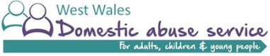**West Wales Domestic Abuse Service**

Refuge, move on accommodation, community support and dedicated children’s worker in Ceredigion. One Stop Shop in Aberystwyth. Also provide Freedom Programme, Recovery Toolkit (adult survivor recovery programmes), STAR programme (children and young people recovery programme for those that have been affected by domestic abuse), and access to counselling.

Cardigan: 01239 615700 Aberystwyth: 01970 612225 One Stop Shop: 42 Portland Road, Aberystwyth