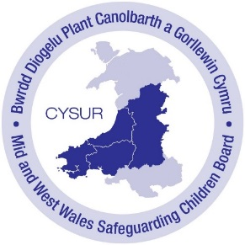
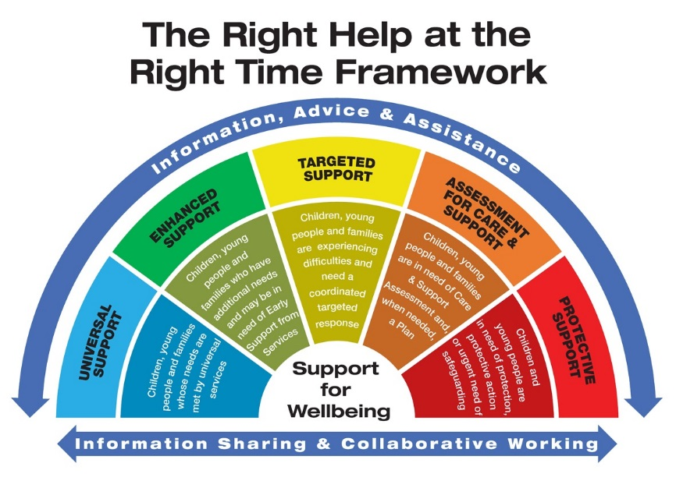

[Local Area] Arrangements & Service Mapping
The below proforma highlights some [Local Authority Area] arrangements and service mapping:
Universal Services | Enhanced Support | Targeted Support | Assessment for Care & Support | Protective Support
GPs | Flying Start | Specialist Safeguarding Health Visitor Flying Start | Tier 3 Services for Substance Misuse | Social Care Safeguarding & Child Protection Teams
Midwifery | Substance Misuse Services | Specialist Safeguarding Health Teams | Looked After Children Service | A&E
Health Visitors | Children and family services | Specialist Safeguarding Midwife | Social Care – Children’s Services | Police
Community Nursing | Team around the family (TAF) | Team around the family (TAF) | Safeguarding Leads in School | Probation
Hospitals | Family Intervention Team (FIT) | Child & Adolescent Mental Health Services (CAMHS) | Youth Justice Teams
Dentists | New Pathways/Workways – Employment assistance | Substance Misuse Services | Protecting Vulnerable People, Police Units
Childcare | Independent Domestic Violence Adviser (IDVA) | Refuge / Safe Accommodation | Probation
Family Centres | Homelessness Options | Counselling Services
Benefits, Financial Services | Victim Support | Safeguarding Leads in School
Housing | Youth Services | Youth Services
Victim Support | Police | Police
Citizens Advice | Families First services | Advocacy Services
Education | Generic Community Support Services | Young Carers
Youth Services | Disability Services | Additional Learning Needs Support
Police | Advocacy Services
Community Social Groups | Supporting People –tenancy support

