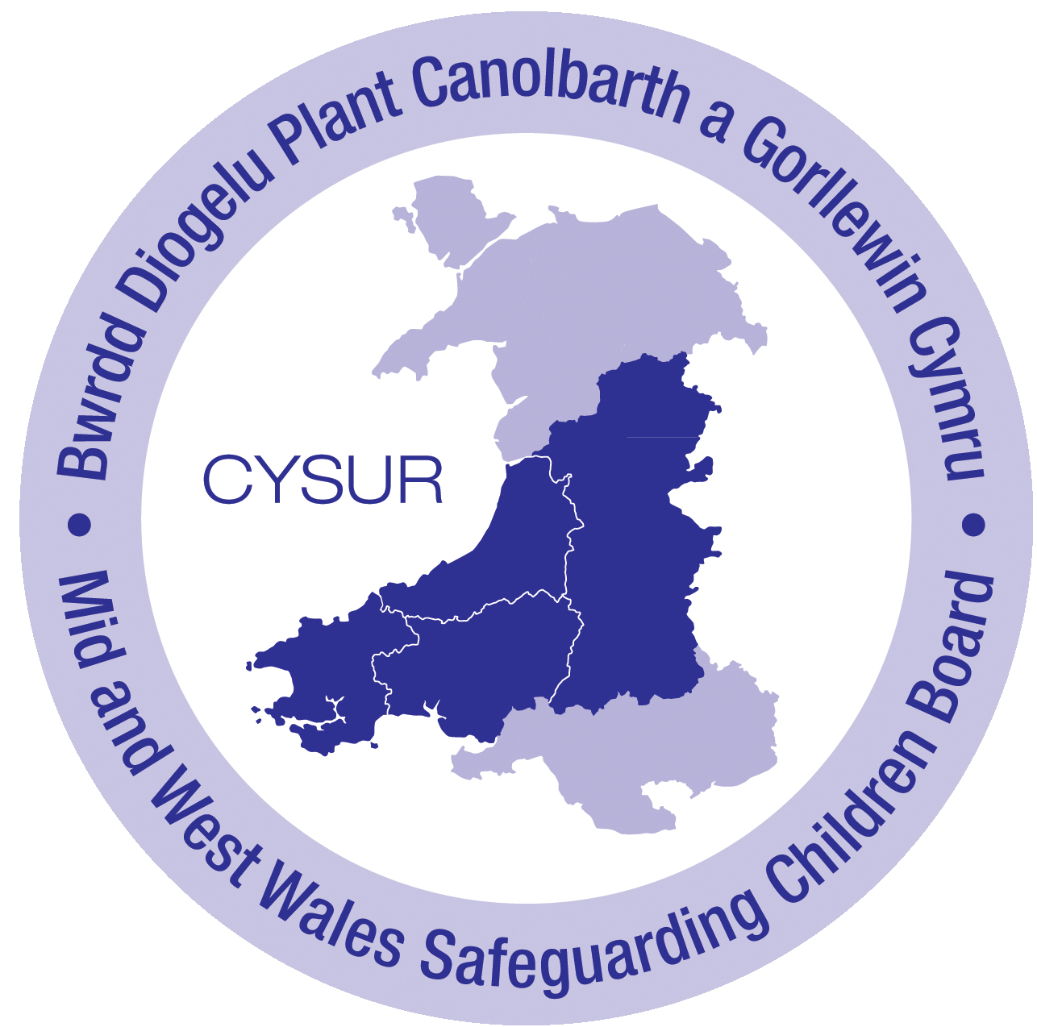
MID & WEST WALES MULTI-AGENCY REFERRAL FORM – Supporting Information
IF THERE ARE IMMEDIATE CONCERNS FOR A CHILD, A REFERRAL SHOULD BE MADE IMMEDIATELY BY TELEPHONE TO THE ASSESSMENT SERVICE / DUTY TEAM. IN SUCH CASES THIS FORM SHOULD THEN BE COMPLETED AND SENT TO THE ASSESSMENT TEAM / DUTY TEAM THE SAME WORKING DAY IN ACCORDANCE WITH ALL WALES CHILD PROTECTION PROCEDURES.

CARMARTHENSHIRE REFERRALS:  - During Office Hours: Central Referral Team – Tel: 01554 742322 Fax: 01554 742176  - Email: CRTChildren@carmarthenshire.gov.uk  - Outside of Office Hours: Careline – Tel: 01558 824283 & 0300 333 2222 | Ceredigion Referrals:  - During Office Hours: Contact Centre – Tel: 01545 574000 Fax: 01545 574002  - E mail: contact-socservs@ceredigion.gov.uk  - Outside of Office Hours: Emergency Duty Team – Tel: 0845 6015392
Pembrokeshire Referrals:  - During Office Hours: Assessment Team – Tel: 01437 776444  - Email: ccat@pembrokeshire.gov.uk  - Outside of Office Hours: Emergency Duty Team – Tel: 08708 509508  [doctors on call answering service take social services calls for out of hours] | POWYS Referrals:  Powys People Direct:  - Tel: 01597 827666  - E mail: people.direct@powys.gov.uk

Guidance for Referral
It is important that referrers refer as much information as they know about the family including a clear reason for referral and what the expected outcome of any intervention should be. The National Assessment Framework should be used as a guide to giving information about the family. It is also important that a balanced picture of the family is given looking at both the vulnerabilities and the strengths of the family.
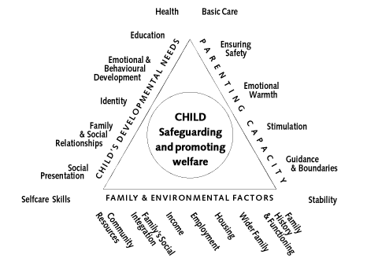
Please read the guidance below regarding the information that is relevant to each domain. Do not be overly concerned regarding ensuring all the information is in the right place. If you are unsure of where some information should go, please add it to any box. It is more important that the information is shared rather than in the right place.

(1) Child/Young person’s Developmental needs
All children change and develop over time. Parents have a responsibility to respond to the child’s needs. The purpose of this section is to identify areas of strength and areas of developmental need, in order to assist you to determine whether this child/young person required services to achieve a reasonable standard of development or to prevent significant impairment of his/her health, and development. Please complete with as much detail as possible, recording strengths as well as difficulties.
Health, education, emotional and behavioural development, identity and social presentation, family and social relationships need to be considered.

(2) Issues affecting parents/carers capacity to respond appropriately to the child/young person’s needs –
The following issues should be explored: providing basic care, ensuring safety, emotional warmth, stimulation, guidance and boundaries, stability, nurturing, bonding, esteem, play opportunities, interest in school.
Research shows that the following are most likely to affect parenting capacity: physical illness, mental illness, learning disability, substance/alcohol misuse, domestic abuse, childhood abuse, history of abusing children. Please record strengths as well as difficulties.

(3) Family & environmental factors which impact on the child and family
The following issues should be explored: Family history and functioning, social/community resources, wider family, housing, employment/income Please record strengths as well as difficulties.
(4) Address
If the child/young person is placed away from their home address, please specify this and clearly specify both addresses to avoid confusion if visits have to be carried out.

Referrers should receive written feedback of the progress of their referral.

**If you have any comments in regard to inaccuracy or additions to this supplementary information or the actual MARF, please contact the Mid & West Wales Safeguarding Board Business Unit at CYSUR@pembrokeshire.gov.uk

