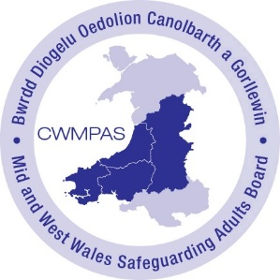
MID AND WEST WALES ADULT SAFEGUARDING REPORT FORM (MARF)

In the case of urgent/immediate risk to an individual, please call the police if applicable.
DETAILS OF PERSON MAKING REPORT:
Name: |  |  | Agency/Role: |  |  |  |  |  |  |  |  |  |  |  |  | Date:
Telephone: |  |  |  |  | Email:
SUBJECT OF REPORT: (Adult at Risk)
Surname: |  |  |  |  |  |  |  | Forename(s): |  |  |  |  |  | Other names used:
PER/WCCIS Number (if known): |  |  |  |  |  |  |  |  |  |  |  | NHS Number (if known):
DOB: | Age: |  |  | Sex: Choose an item. |  |  |  |  | Gender: Choose an item. |  | Ethnicity: |  |  |  |  |  |  | Preferred Language:
Address Currently Residing: |  |  |  |  |  |  |  |  |  |  |  |  |  |  |  |  |  | Post code: |  | Telephone:
Other adults or children at the property (please give details): |  |  |  |  |  |  |  |  |  |  | Are they considered also at risk? Choose an item. |  |  |  |  |  | If yes, have any MARFs been submitted for them? Choose an item.
GP’s Name: |  |  |  |  |  |  | Surgery Address: |  |  |  |  |  |  |  |  |  | Telephone:
If concerns relate to a person in a position of trust, please specify below:
Name |  | Address |  |  |  | Organisation (employment or voluntary) |  |  |  |  | Date of Birth |  | Relationship to person |  |  |  |  | Telephone | Any other relevant information
MAIN CLIENT GROUP: (Adult at Risk)
Older Person  Visual Impairment  Hearing impairment |  |  | Learning Disability  Physical Disability |  |  |  |  |  |  | Mental Health (Under 65)  Mental Health (Over 65)  Substance Misuse |  |  |  |  | Communication difficulties (please specify):  Other (Please specify):
Any other relevant information regarding the person’s health status (if known):

CARE AND SUPPORT NEEDS, CAPACITY AND CONSENT
Please explain clearly the person’s current care and support needs (whether or not any services are currently in place): |  |  | If relevant and known, who provides this:
Please explain clearly why the adult at risk cannot protect themselves. Please provide specific detail and give examples if possible.
What action has been taken to safeguard the adult at risk?
Is there any evidence to suggest that the adult at risk lacks mental capacity to consent to this report? Choose an item.
If the adult at risk has capacity, do they consent to their information being shared with other agencies? Choose an item.
Is there an overriding reason to share this concern without consent? (e.g. a crime has been committed, others may be at risk) Choose an item. |  | If yes, please explain why:
Is the adult at risk aware of the report? Choose an item.  If not, please explain why: | Has the adult at risk been informed that their information will be shared without consent, where necessary? Choose an item.
What are the views and wishes of the adult at risk? What would the adult at risk like as an outcome to this report? What would they like to happen?

ABOUT THE ALLEGED ABUSE:
Type of alleged abuse: (tick all relevant boxes) Physical Sexual Emotional/Psychological Financial/Material Neglect Domestic Abuse At risk of radicalisation
At risk of modern slavery If yes, has an NRM been submitted? Choose an item.
Honour-based violence If yes, has a MARAC referral been raised? Choose an item.
Is this Organisational / Institutional Abuse? Choose an item.
If the concerns impact on three or more service users, then only one referral is necessary, but details of all individual adults at risk must be recorded below.
If yes, please give further detail.
Where did the alleged abuse occur?
Own Home Care Home - Residential Care Home – Nursing Care Home – Respite Relative’s Home
Supported Tenancy Hospital Hospital – Independent NHS Trust Group Home Home of Perpetrator Day care Educational Sheltered Accommodation Hospice Public Place Other - Please State:
Is the abuse: Historical Current | Additional risks/concerns? Choose an item. If yes, please specify.

Please specify the reason why you are reporting a concern and what the risks are.
Please specify what has prompted you to submit the report, e.g. I have witnessed something that has concerned me; someone has passed information on to me that has worried me; I feel the person needs some help now to stop the situation escalating to something more serious; the person is alleging abuse or neglect etc. Please also detail the issue you feel needs to be addressed e.g. Physical abuse, emotional harm. Where possible provide specific examples of your identified concerns/needs.
What is working well? What are the person’s strengths?
Consider family/community networks/protective safe adults and relationships/wider support networks/engagement with services/agencies/existing care and support plan/package in place.

DESCRIPTION OF ALLEGED PHYSICAL OR SEXUAL ABUSE OR INJURIES (WHERE RELEVANT):
Please provide details of any injuries, marks, bruising, wounds etc:
Please use this section to identify the position of any marks, bruising, wounds etc – for electronic referrals, drag circle over area & relate number to description of injury above.
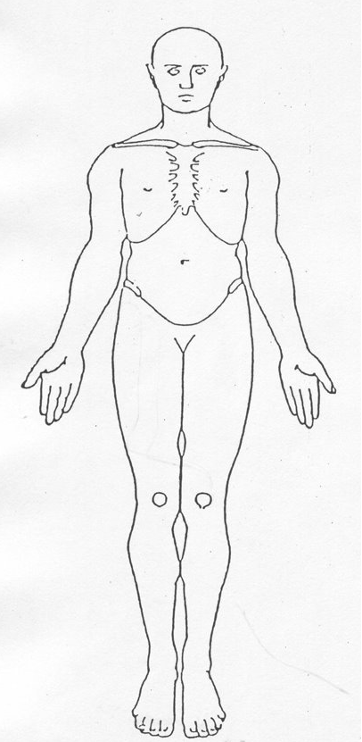  1  2  3 | 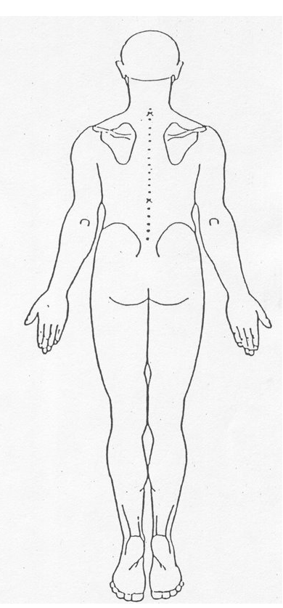  4  5  6

ABOUT THE PERSON(S) ALLEGEDLY RESPONSIBLE FOR THE ABUSE:
Please note this section does not need to be completed if the person allegedly responsible is in a position of trust. In such cases please complete the relevant section in ‘Subject of Report’ on Page 1.
Unknown at present: Choose an item. |  |  | More than one alleged person responsible? Choose an item. (Add details in additional information)
Name: |  | Address: |  | Telephone:
DOB: | Age: | Relationship to Alleged Victim:
Is the alleged person responsible an adult at risk? Choose an item.
If the alleged person responsible is an adult at risk, do they have capacity to understand their actions? Choose an item.

Does the reporter wish to remain anonymous? Choose an item. | If yes, explain why: (excludes professionals)

ADDITIONAL INFORMATION:

Guidance Notes

An “Adult at risk” is a person aged 18 years or over who
- Is experiencing or is at risk of abuse or neglect and
- Has a need for care and support (whether or not these are currently being met) and
- As a result of those needs is unable to protect himself against the abuse or neglect or the risk of it
Adults at risk may have or may lack mental capacity to make specific decisions. The Mental Capacity Act 2005 specifies that:
“A person lacks capacity in relation to a matter if at the material time he is unable to make a decision for himself in relation to the matter because of an impairment of, or a disturbance in the functioning of, the mind or brain”
A person is assumed to have capacity unless he/she is assessed as unable to do any one of the following:
- Understand the information relevant to the decision; or
- Retain information; or
- Use or weigh that information as part of the process of making the decision; or
- Communicate their decision (whether by talking, using sign language, writing etc)

NOTE: Be aware of information security when sharing or emailing this completed document and ensure you adhere to data protection principles and boundaries of confidentiality.

